Analysis Plan

Main analysis
- Definition of t0 = days_to_terli_initiation_day0
- Outcome window: days_to_terli_initiation_day0 to *day90_dt
New Variables:
  - day90_dt = days_to_terli_initiation_day0 + 90
  - vitalstatus90:
- if disposition==5 AND (days_to_discharge - days_to_terli_initiation_day0) ≤ 90, OR if dc_death_90days==1 and ((dc_days_to_death+ days_to_discharge)- days_to_terli_initiation_day0) ≤ 90
- dc_death_90days==0 or dc_death_90days==1 AND ((dc_days_to_death+ days_to_discharge)- days_to_terli_initiation_day0) > 90
- dc_days_lastencounter < day90_dt or days_to_lost_to_followup < day90_dt
- day0_meld_3_cat:
- day0_meld_3 <20
- day0_meld_3 ≥20 and day0_meld_3≤30
- day0_meld_3>30
  - dc_lt90_date: time_to_transplant
  - dc_MELD:( dc_scr, dc_sna, dc_albumin, dc_tbili, dc_inr, sex_male (0 for female)
  - dc_MELD_3
  - dc_MELD_Na
  - delta_meld3 = dc_meld_3- day0_meld_3
  - dc_lastencounter_days: (dc_days_to_death+ days_to_discharge)- days_to_terli_initiation_day0
  - dc_losttofollowup_days: (days_to_lost_to_followup+ days_to_discharge)- days_to_terli_initiation_day0
- How do the various prognostic scores perform in predicting thge primary outcome of 90-day mortality for this specific patient population?
  - Table 1 Baseline Demographics and Clinical Characteristics by 90-day Survival Outcome
    - Columns
      - # alive at 90 days from admission (vitalstatus90=1)
      - # dead by 90 days from admission (vitalstatus90=2)
      - All/entire cohort N=243
      - P values comparing alive with dead
    - Rows
      - age (median, IQR)
      - sex_male = 1 (n, %)
      - race (n, %)
        - race=1
        - race=2+3+4
      - hispanic=1 (n, %)
      - etoh_hepatitis=1 (n, %)
      - cirrhosis_etiology (categorial, for each n, %)
        - cirrhosis_etiology=1
        - cirrhosis_etiology=2
        - cirrhosis_etiology=3
        - cirrhosis_etiology=4
        - cirrhosis_etiology=5
        - cirrhosis_etiology=6
      - admit_reason (categorial, for each n, %)
        - admit_reason=1
        - …
        - admit_reason=7
      - day0_meld_3 (median, IQR)
      - day0_meld_3_cat(n, %)
      - day0_meld_3 , tertiles (n, %)
        - 1st tertile
        - 2nd tertile
        - 3rd tertile
      - dc_MELD_3
      - delta_meld3
      - admit_meld_na
      - clif_c_score
      - aclf_grade
      - Complications of cirrhosis
        - refascites_previous_comp=1
        - sbp_previous_comp=1
        - phtn_bleed_previous_comp=1
        - he_previous_comp=1
        - nonsbp_previous_comp=1
      - HRS_reversal_new
      - RRT during admission (n, %)
        - rrt=0
        - rrt=1
        - rrt=2
  - CIF curves plotting survival probability over time horizon of 90 days from admission with LT as competing event
Inputs: days_to_terli_initiation_day0, day90_dt (above), time_to_death, time_to_transplant, dc_lastencounter_days, dc_losttofollowup_days
    - Responders only: hrs_responders_cat_2=1
    - Non-responders only: hrs_responders_cat_2 =0
    - All (N=243)
    - Excluding transfers (transfer_aki=0 only)
  - Table 2 Fine and Gray Subdistribution Hazard Ratios for 90-Day Mortality with LT as a Competing Risk
    - Time origin: days_to_terli_initiation_day0 ; follow-up through day90_dt
    - Event of interest: time_to_death
    - Competing event: time_to_transplant_90days
    - Predictors, evaluate each separately – day0_meld, day0_meld_na, day0_meld_3, clif_admit
      - Treat as continuous per 1-point increase
    - Fit a Fine and Gray sub-distribution hazard model for each score
    - Obtain unadjusted sHR, 95% CI and p values for each prognostic score and tabulate in a table
    - Add columns for every 3-point increase with sHR, 95% CI
      - Post-hoc from the per-1-point model: if sHR₁ = exp(β) and 95% CI = exp(β ± 1.96·SE), then
sHR₃ = exp(3β) = (sHR₁)³ and 95% CI₃ = exp(3(β ± 1.96·SE))
    - Example output
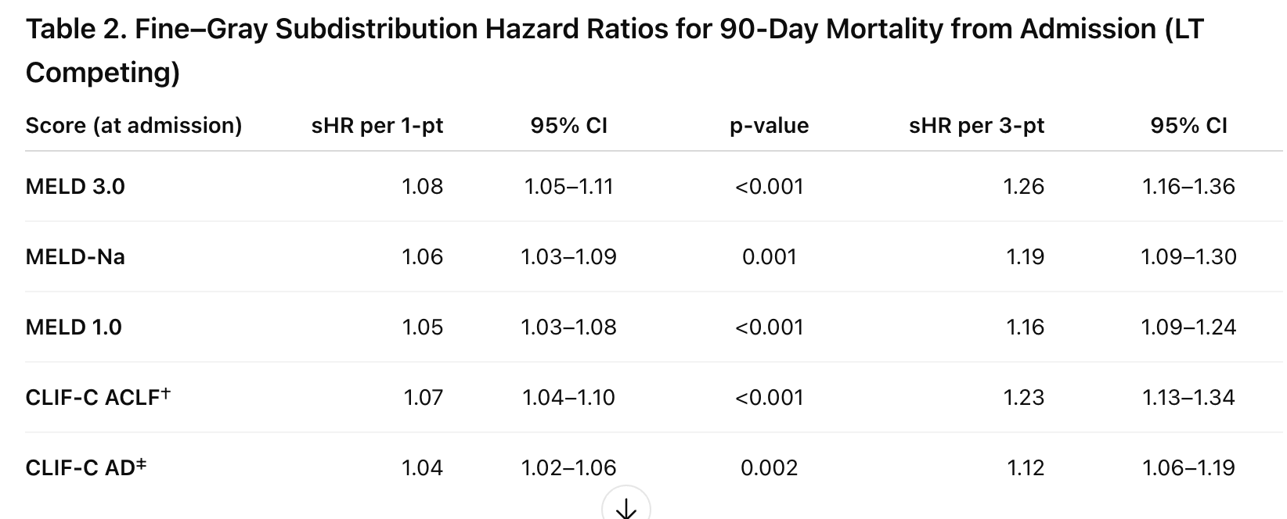

  - Table 3 Discriminative Performance of Prognostic Models for 90-Day Mortality with LT as a Competing Risk
    - Outcome set up and F/G models same as for Table 2
    - AUC (90 days)
      - From each FG model, compute the predicted cumulative incidence of death by 90 days for every subject in that model’s analysis set
      - Compute time-dependent AUC at τ = 90 d using IPCW (treat LT and right-censoring as censoring for death)
      - Bootstrap 95% CIs with paired resampling (≥1000 subject-level resamples).
      - For ΔAUC vs day0_meld_3, compute the difference within each bootstrap sample (paired), report Δ and p-value
    - iAUC (0 – 90 days)
      - compute time-dependent AUC(t) over 0→90 and integrate to obtain iAUC (0 – 90 days) with paired bootstrap Δ vs meld3_admit
    - Harrell-type concordance computed on the Fine–Gray model’s linear predictor (to match MELD 3.0 paper)
      - Compute Harrell’s concordance, boostrap 95% Cis
      - For ΔC vs meld3_admit, calculate the paired difference in each bootstrap sample; report Δ and p-value
    - Sample table output
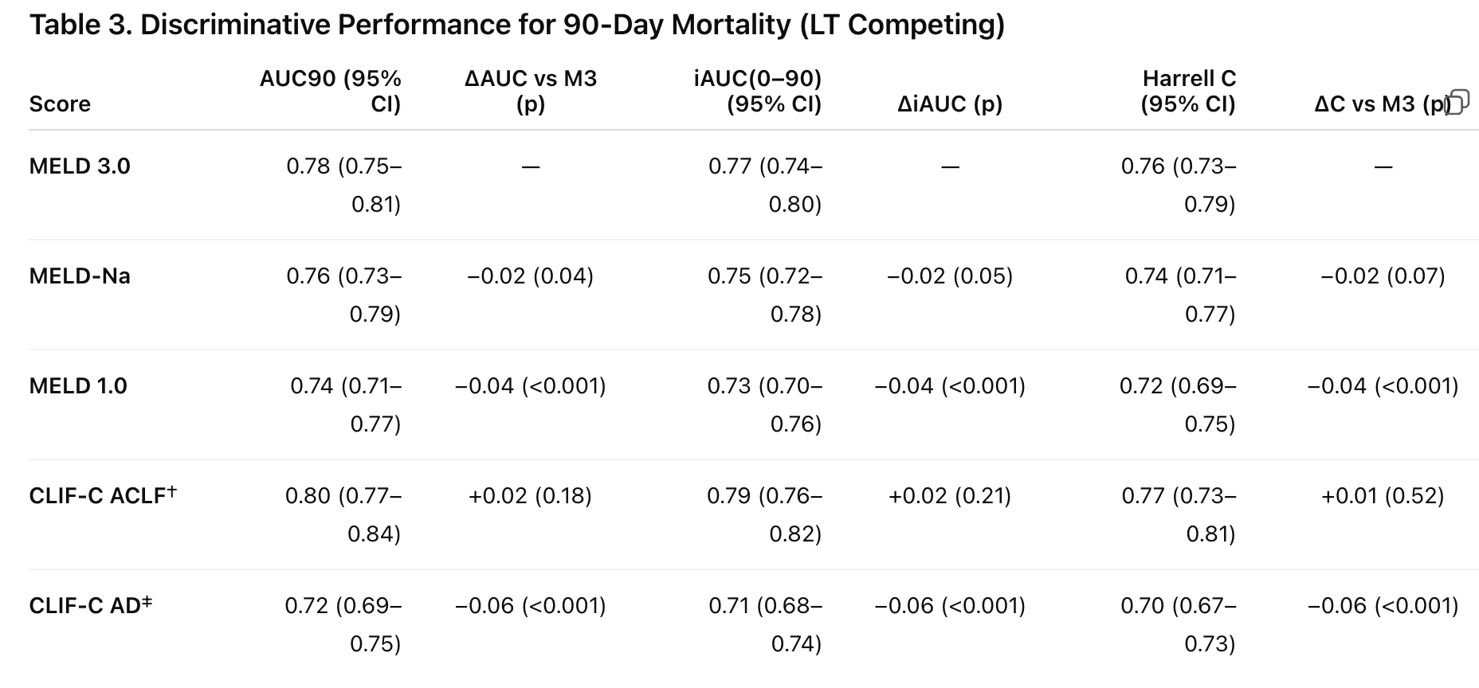

  - Calibration Curves Assessing Agreement Between Predicted and Observed 90-Day Mortality for Prognostic Scores
    - For each score ( day0_meld, day0_meld_na, day0_meld_3, clif_aclf_admit, clif_ad_admit), group patients into ? quintiles (tertiles if events sparse) based on predicted 90-day mortality
    - Compute mean predicted 90-day mortality using the same Fine and Gray models as above, with LT as competing risk
    - Estimate the observed 90-day cumulative incidence of death (LT as competing risk) using CIF
    - Plot predicted versus observed for each score
- How do the various scores perform in predicting the secondary outcome of RRT needs during hospitalization?
  - Table 4 Sub-distribution Hazard Ratios and C-Indices of Prognostic Scores for Predicting In-Hospital RRT with Death and LT as Competing Risk
    - Variables
      - days_to_terli_initiation_day0
      - days_to_discharge
      - rrt — 1 if RRT occurred during the index admission; 0 otherwise (will lump rrt=2 with rrt=0)
      - rrt_date
      - time_to_death (use as competing event only if it occurs before discharge)
      - time_to_transplant_90days (use as competing event only if it occurs before discharge)
    - Fit a separate Fine–Gray model (event=rrt, competing = LT or death before) for each score: day0_meld, day0_meld_na, day0_meld_3 and clif_aclf_admit / clif_ad_admit
    - Compute and report sHR (per 1-point) with 95% CI, p value
    - Compute and report Harrell’s C with 95% CI
    - Sample table output
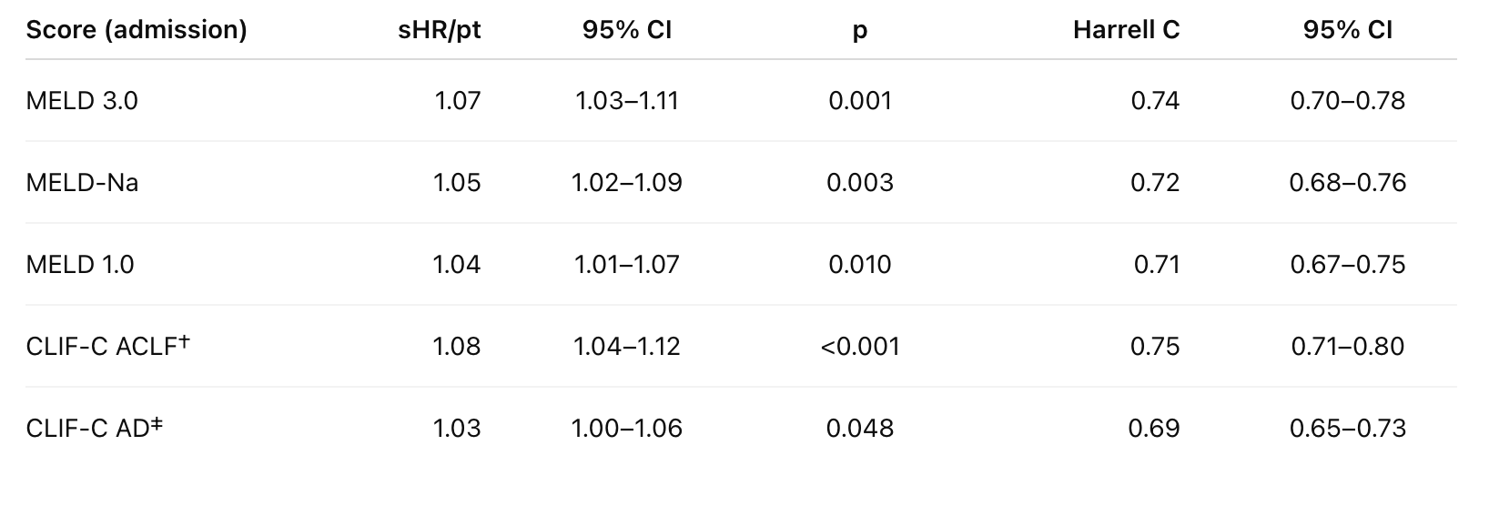

Additional Analysis:
Separately (not in this Table), could we see a distribution of delta_meld3 in terms of histogram?

STOP HERE

Sensitivity with time 0 defined aki_date
Exclude transfers
Scores re-computed at aki_date
Makes CLIF-C scores easier

